Question 3

**3.1.**

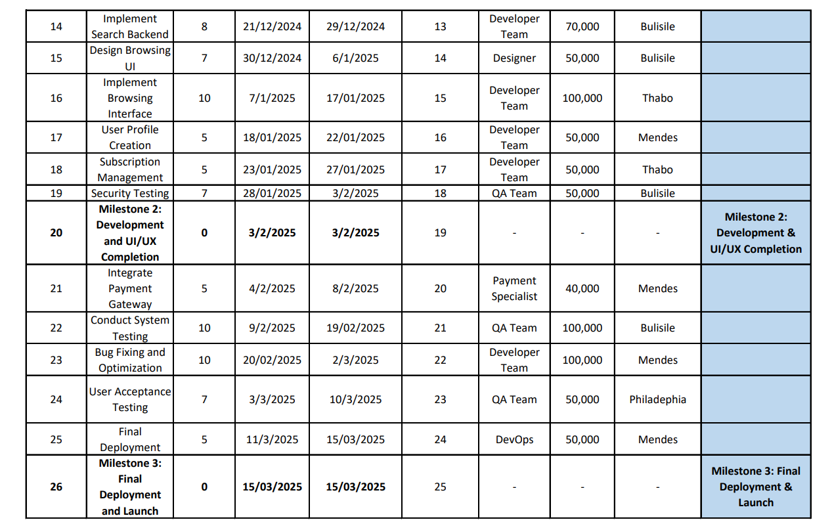

**Grantt Chart**

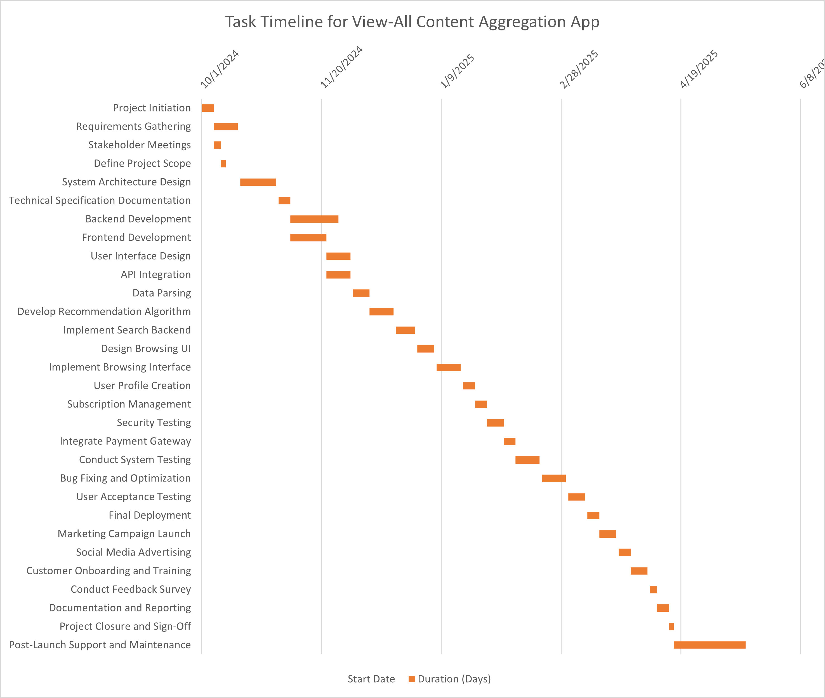

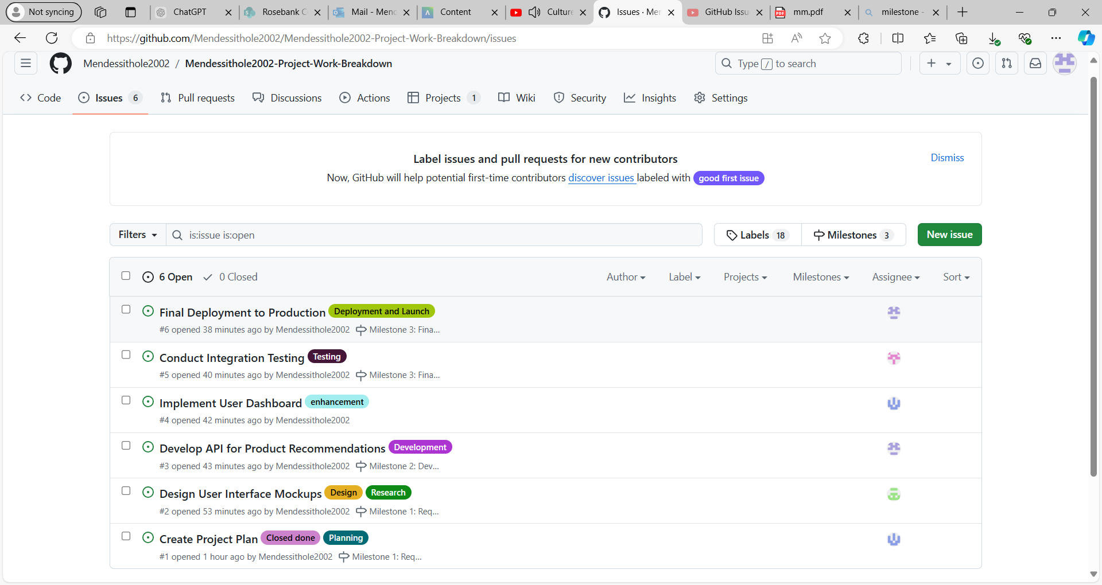**Q.3.2.**

Link to Github: <https://github.com/Mendessithole2002/Mendessithole2002-Project-Work-Breakdown/issues>

(Note: in any case when you click on the link and does not direct you to Github,kindly do the following: Click the on CTRL BUTTON on your keyboard at the same time clicking on the link)